OS&D
REMINDER OF THE WEEK
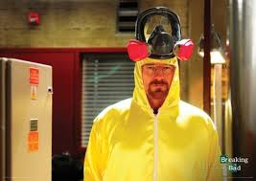
WALTER WHITE IN “BREAKING BAD” WORE A HAZMAT SUIT IN HIS LINE OF WORK. LME DOESN’T REQUIRE OUR OS&D GROUP TO WEAR SUITES BUT WE DO OFFER SAFETY PRECAUTIONS SUCH AS MASKS, LINERS, RECOVERY DRUMS & EACH TERMINAL SHOULD HAVE A HAZMAT STATION FOR EYE SOLUTIONS.
WHEN YOU DEAL WITH ANY HAZMAT, PRECAUTIONS NEED TO BE YOUR FIRST PRIORITY. ANY LEAKING PRODUCT MUST BE CONTAINED…..THEN WE NEED TO GET DISPOSITON FROM THE SHIPPER/3RD PARTY FOR A RETURN. IF THE SPILL DOES NOT ALLOW A RETURN, REQUEST THE SDS, COMPLETE THE HAZMAT FORM AND FORWARD BOTH DOCUMENTS TO SAFETY AT CSENFTNER@LME4ME.COM. SAFETY WILL ADVISE WHAT YOU SHOULD DO WITH THE SPILL.
